#### Forecast error variance decomposition

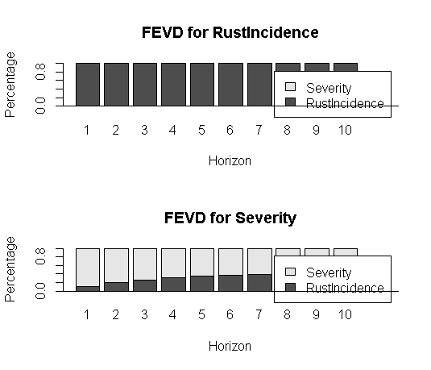

Fig- 3.14 – FEVD for rust incidence and severity for variety S795

The FEVD plot for rust incidence shows that severity does not play any part in contributing to the forecast of rust incidence in the future while FEVD for severity shows that rust incidence does play a part in contributing to the forecast of severity in near future. A very small part of error variance is contributed by rust incidence in all ten lags in the future.

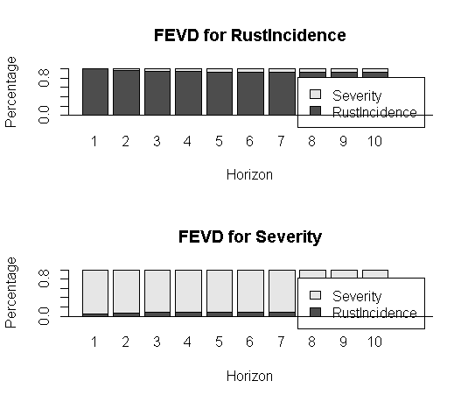

Fig- 3.23 – FEVD for rust incidence and severity for variety Sln5B

The FEVD plot for rust incidence shows that severity does not play any part in contributing to the forecast of rust incidence in the future while FEVD for severity shows that rust incidence does play a part in contributing to the forecast of severity in near future. A very small part of error variance is contributed by rust incidence in all ten lags in the future.

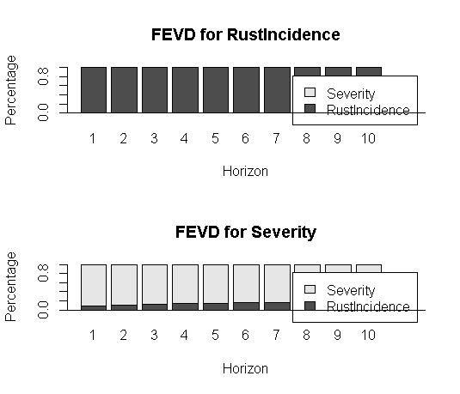

Fig- 3.31 FEVD for variety CXR

The FEVD plot for rust incidence shows that severity does not play any part in contributing to the forecast of rust incidence in future.

The FEVD plot for severity shows that rust incidence does play a part in forecasting severity in the future. A very small part of error variance is contributed rust incidence in all the ten lags in future.